Domayne’s Net Grey comfort Sofa

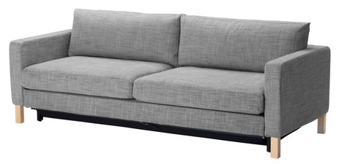

|  |
| --- |
| **DESCRIPTION** |
| Intense comfort Sofa produced by Domayne’s Sofa, presents a sleek and stylish which will add mass affection in homes and TV lounge perfect for a silent rest. The extra length of this sofa enables your body to adjust easily at will. Available in Leather and cloth material, bulky form and hand stitched leather cloth. |

|  |  |  |
| --- | --- | --- |
| **Price** | **3675$** | |
| **Dimensions** | **H** x **W** x **L** | **35in x 32in x 68in** |
| **Features** | **Grey contains feature and color of both white and black which means it will adjust to the temperature of both summer and winter.** | |
| **Finished** | **Net cloth Finished** | |
| **Available in** | **Grey and dark Brown** | |